Gall bladder wall thickening and platelet count to spleen diameter ratio as noninvasive predictors of oesophageal varices (OV) in patients with liver cirrhosis
Osama Ahmed Ibrahim
R version 4.5.1 (2025-06-13) was used to conduct the analysis. Visual Inspection and Shapiro-Wilk test were performed to assess normality of data to determine the appropriate statistical tests. Data not normally distributed was presented by median and interquartile range. Receiver operating characteristic (ROC) curve analysis was performed to evaluate gall bladder wall thickness (GBWT) and the platelet count-to-splenic diameter ratio as noninvasive predictors of oesophageal varices (OV) among 100 cirrhotic patients (50 with OV and 50 without OV, defined by upper endoscopy). ROC curves were constructed in R using the pROC package, and diagnostic discrimination was quantified by the area under the ROC curve (AUC). Optimal cut-off values for each marker were determined using Youden’s index (maximizing sensitivity + specificity), and the corresponding sensitivity, specificity, positive predictive value (PPV), and negative predictive value (NPV) were reported. Two-sided p-value <0.05 was considered statistically significant.

Baseline clinical and laboratory characteristics of cirrhotic patients with and without oesophageal varices
Characteristic | Overall  N = 100¹ | No Varices  N = 50¹ | With Varices  N = 50¹
Age | 55 (49, 63) | 54 (49, 61) | 55 (50, 65)
Sex
Male | 59 (59%) | 23 (46%) | 36 (72%)
Female | 41 (41%) | 27 (54%) | 14 (28%)
Child-Pough Score
A | 65 (65%) | 45 (90%) | 20 (40%)
B | 21 (21%) | 3 (6.0%) | 18 (36%)
C | 14 (14%) | 2 (4.0%) | 12 (24%)
Ascitis | 29 (29%) | 4 (8.0%) | 25 (50%)
Platelet Count | 160 (139, 198) | 180 (159, 223) | 139 (100, 166)
INR | 1.10 (0.90, 1.60) | 1.00 (0.84, 1.28) | 1.60 (1.00, 1.90)
Spleen Diameter | 120 (112, 141) | 115 (112, 121) | 141 (119, 154)
PV diameter(mm) | 11.95 (10.90, 13.80) | 11.35 (10.70, 12.00) | 13.75 (11.90, 14.60)
Gall Bladder Wall Thickness (mm) | 3.15 (2.60, 4.20) | 2.80 (2.00, 3.30) | 4.20 (3.00, 4.90)
Platelet count to spleen diameter ratio | 1,354 (983, 1,693) | 1,605 (1,364, 1,916) | 984 (673, 1,345)
Portal Hypertension Gastropathy | 41 (41%) | 6 (12%) | 35 (70%)
Albumin | 3.50 (3.20, 3.60) | 3.55 (3.50, 3.70) | 3.25 (3.00, 3.50)
¹Median (Q1, Q3); n (%)
Patients with OV had significantly higher gall bladder wall thickness (median 4.20 vs 2.80 mm, p < 0.001) and significantly lower platelet count-to-spleen diameter ratio (median 984 vs 1,605, p < 0.001) compared with patients without OV. The OV group also showed more advanced liver disease features, including worse Child–Pugh class distribution and higher prevalence of ascites (50% vs 8.0%, p < 0.001), alongside lower platelet count and higher INR (both p < 0.001).

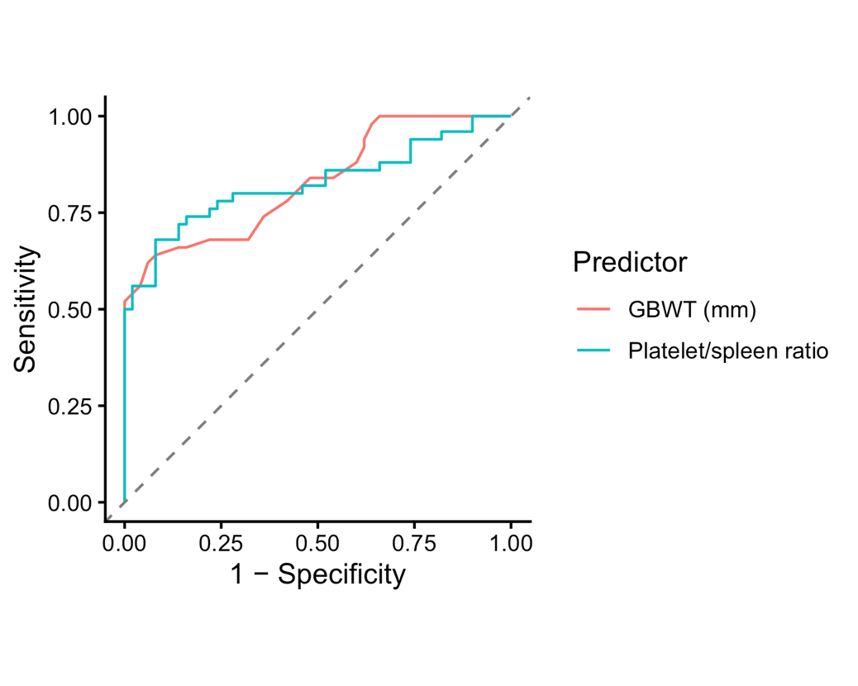
ROC curves of gall bladder wall thickness and platelet count-to-spleen diameter ratio for predicting oesophageal varices.
ROC analysis demonstrated good discrimination for both markers, with AUC 0.8280 for GBWT and AUC 0.8256 for the platelet count-to-spleen diameter ratio. There was no statistical significant difference between the two AUCs (p = 0.9392).

Diagnostic performance of GBWT and platelet count-to-spleen diameter ratio at the optimal (Youden) cut-off values
Predictor | AUC | Cutoff | Sensitivity | Specificity | PPV | NPV
GBWT (mm) | 0.828 | 3.75 | 0.64 | 0.92 | 0.889 | 0.719
Platelet / spleen ratio | 0.826 | 1,204.00 | 0.68 | 0.92 | 0.895 | 0.742
At the optimal cutoff, GBWT > 3.75 mm yielded sensitivity 0.64 and specificity 0.92, with PPV 0.8889 and NPV 0.7188. The platelet count-to-spleen diameter ratio cutoff ≤ 1,204.00 yielded sensitivity 0.68 and specificity 0.92, with PPV 0.8947 and NPV 0.7419.

